# Part II. Single Node Installation and Configuration

# Chapter 3. WebSphere V6 Standalone Application Server: Install, Configure, and Verify

One of the core tasks involved in building the WebSphere architecture we described in [Chapter 2](https://www.safaribooksonline.com/library/view/websphere-application-server/9781583470619/ch02.html) — a highly available, workload-managed (HA/WLM), clustered application server environment — is to set up a standalone application server. You can perform this task using any of the available packages of WebSphere Application Server V6: Express, Base, or Network Deployment. To use Network Deployment features such as clustering, you must upgrade the Express or Base package to the Network Deployment package.

The process of creating, verifying, configuring, and managing the standalone application server is the same whether you use the Base/Express package or the Network Deployment package. In this chapter, we step you through the install process for WebSphere V6 – Base/Express and show you how to create, configure, and verify the application server profile that’s created using the binaries that are copied to disk when you install this package. (For a reminder of the relationship among product binaries, profiles, profile templates, and application servers, see [Chapter 1](https://www.safaribooksonline.com/library/view/websphere-application-server/9781583470619/ch01.html).)

[Chapter 7](https://www.safaribooksonline.com/library/view/websphere-application-server/9781583470619/ch07.html) covers the Network Deployment version of this process. Before using the Network Deployment package to create a standalone application server, we strongly advise you to read the present chapter from beginning to end to gain a complete understanding of the standalone application server and how it works. Consider this chapter a prerequisite to understanding the topics covered in[Chapter 7](https://www.safaribooksonline.com/library/view/websphere-application-server/9781583470619/ch07.html). We’ll refer to parts of this chapter to perform most of the steps required in [Chapter 7](https://www.safaribooksonline.com/library/view/websphere-application-server/9781583470619/ch07.html) to create and manage the application server profiles for the sample HA/WLM environment.

# Installation Essentials

It’s important to understand that the WebSphere V6 installation process has two phases:

* Phase 1 — Copying the product binaries to an installation directory you specify during the installation. Throughout the book, we represent this directory as <WASV6-ROOT>.
* Phase 2 — Creating, under the <WASV6-ROOT>\profiles directory, a default profile (called ‘default’) that defines the runtime environment (set of files) for an application server process (server1). Throughout the book, we represent the profiles directory as <PROFILE-ROOT>.

[Table 3-1](https://www.safaribooksonline.com/library/view/websphere-application-server/9781583470619/ch03.html#ch03table01) provides a key, by operating system, to the directory locations for the symbolic directory references we use in our discussions.

**Table 3-1. Directory locations for symbolic references**

| **Symbolic reference** | **Windows** | **AIX** | **Linux/Unix** |
| --- | --- | --- | --- |
| <WASV6-ROOT> | C:\IBM\WebSphere\AppServer | /usr/WebSphere/AppServer | /opt/WebSphere/AppServer |
| <PROFILE-ROOT> for default profile | <WASV6-ROOT> \profiles\default | <WASV6-ROOT> /profiles/default | <WASV6-ROOT> /profiles/default |
| <NEW-PROFILE-ROOT> for profile added after AppSrv01 install | <WASV6-ROOT> \profiles\AppSrv01 | <WASV6-ROOT> /profiles/AppSrv01 | <WASV6-ROOT> /profiles/AppSrv01 |

For the Base and Express packages, both phases of the install process are performed automatically for you during installation. If you use the Network Deployment package, the installation process performs only Phase 1 — copying the product binaries to the installation directory. You must then use the Profile Creation wizard or the wasprofile command-line utility to create a profile (Phase 2) yourself. For this reason, you won’t see the default application server profile after installing the ND package.

[Figure 3-1](https://www.safaribooksonline.com/library/view/websphere-application-server/9781583470619/ch03.html#ch03fig01) shows the architecture and components that are created after you successfully install the application server using the Base/Express package.

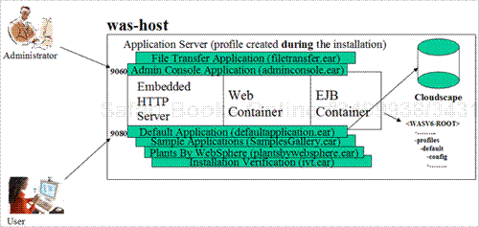

**Figure 3-1. Architecture and components created after installation of the Base/Express application server**

As a result of the installation process, the following elements are created:

* product binaries and a configuration repository, all stored in the file system. (WebSphere V6 doesn’t require a database to store the configuration repository.)
* a default profile (default) containing an application server (server1).
* file transfer and administrative console applications on the default application server (server1). You use these applications to make changes to the configuration repository. By default, the applications are available at administrative port 9060.
* the DefaultApplication application (consisting of the snoop, hello, and hitcount servlets) and an installation verification application on the default application server (server1). You use these applications to verify installation and configuration. By default, the applications are available at HTTP transport port 9080. The Cloudscape database is also installed to support container-managed persistence (CMP) entity beans in the hitcount application.
* optionally, the SamplesGallery and PlantsByWebSphere applications, if you choose to deploy these additional sample applications during the installation.

# Installing WebSphere Application Server V6 Using the Base/Express Package

The flow chart in [Figure 3-2](https://www.safaribooksonline.com/library/view/websphere-application-server/9781583470619/ch03.html#ch03fig02) depicts the high-level steps required to install, configure, and verify the application server profile for the standalone application server. In this section, we walk you through each step of this process.

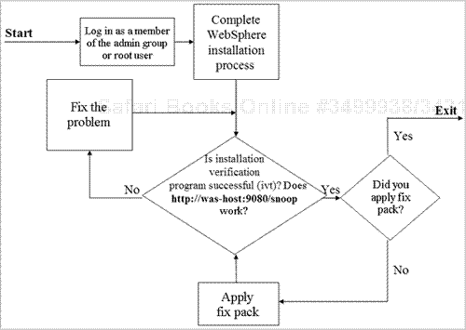

**Figure 3-2. Base/Express installation overview**

Our instructions assume that you’re working in a Windows XP environment. If you’re using a Unix operating system to perform the steps, you’ll need to execute the appropriate commands for your operating system (i.e., .sh instead of .bat) and substitute the forward slash (/) for the backward slash (\) in directory and path names. We’ll point out other differences for Unix in “Unix Notes” as needed. Now let’s get started.

1. If you plan to use the trial version of the WebSphere Base or Express package, your first step is to register for and download the software from the Web. The trial version is good for 60 days, and you can submit a problem ticket to IBM support during the trial period. For more details about the trial version and to download the software, go to either of the following URLs:

[*http://www-106.ibm.com/developerworks/websphere/downloads*](http://www-106.ibm.com/developerworks/websphere/downloads)

[*http://www14.software.ibm.com/webapp/download/home.jsp*](http://www14.software.ibm.com/webapp/download/home.jsp)

[Figure 3-3](https://www.safaribooksonline.com/library/view/websphere-application-server/9781583470619/ch03.html#ch03fig03) shows how the directory structure looks after you’ve downloaded the trial version of the Base package and extracted the files to a temporary directory. Note the location of the Launchpad program (launchpad.bat on Windows, launchpad.sh on Unix). This Web application is the starting point for installing all WebSphere Application Server products. If you’re using the licensed Base or Express package, you’ll find the Launchpad program in the root directory of the WebSphere product CD.

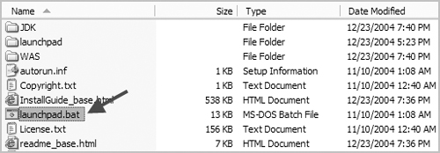

**Figure 3-3. Directory structure for Base package trial version**

1. Log in to your Windows system as a member of the Administrators group. On the Windows desktop, right-click **My Computer**, select **Properties**, and go to the **Advanced** tab. Click the**Environment Variables** button to display the user and system variables. In the “User variables for user” list, note the value set for the temporary directory, TMP. The WebSphere installation program uses this directory to store temporary files during the installation.

If you don’t see TMP in the variable list, click **New** to add the variable. In the window shown in[Figure 3-4](https://www.safaribooksonline.com/library/view/websphere-application-server/9781583470619/ch03.html#ch03fig04), variable TMP has been edited to point to directory C:\temp.

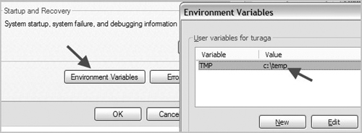

**Figure 3-4. TMP variable set to directory C:\temp**

### **Unix note**

On Unix systems, log in as root. If necessary, run the command **umask 022** to set permissions for the temporary directory (usually /tmp on these systems). You can verify the current umask setting by running **umask** with no arguments.

1. The WebSphere Base/Express V6 product requires a minimum of 1,030 MB of disk space: 100 MB for the temporary directory and 930 MB for the installation root directory (<WASV6-ROOT>). Before proceeding with the installation, verify that your system meets this minimum space requirement.

### **Unix note**

Make sure the file systems mounted on the temporary and installation directories meet the minimum disk space requirements of 100 MB and 930 MB, respectively.

1. If you’re using the licensed Base or Express package, insert the product CD and navigate to the directory where the Launchpad program is located. If you’re using the trial version of the software, navigate to the temporary directory containing the downloaded product files.

To start the installation wizard, double-click **launchpad.bat**. (As an alternative, you can invoke the install.exe program under the WebSphere directory where you downloaded the installation product files.)

From the moment you invoke it, the Launchpad program begins logging information about your installation activities under the TMP directory. If you have trouble starting the Launchpad (or install.exe) or encounter problems during the early part of the installation, consult this log. To learn more about WebSphere logging, see the “[Logging: Problem Determination and Troubleshooting](https://www.safaribooksonline.com/library/view/websphere-application-server/9781583470619/ch03.html#ch03lev1sec7)” section of this chapter.

### **Unix note**

Before starting the Launchpad on a Unix system, make sure you can execute the **xclock**or **xeyes** command to display one of the graphical images shown in [Figure 3-5](https://www.safaribooksonline.com/library/view/websphere-application-server/9781583470619/ch03.html#ch03fig05). If you have a problem displaying the image, set the terminal emulation properly. If you can display these images but can’t start the Launchpad, consult “[Logging: Problem Determination and Troubleshooting](https://www.safaribooksonline.com/library/view/websphere-application-server/9781583470619/ch03.html#ch03lev1sec7)” for more information.



**Figure 3-5. Images displayed by xclock and xeyes commands**

1. The Launchpad program displays an initial welcome panel similar to the one shown in [Figure 3-6](https://www.safaribooksonline.com/library/view/websphere-application-server/9781583470619/ch03.html#ch03fig06). If you’re using the licensed package, you’ll see additional options (e.g., HTTP Server, Plug-in, AST) on the left side of this panel.

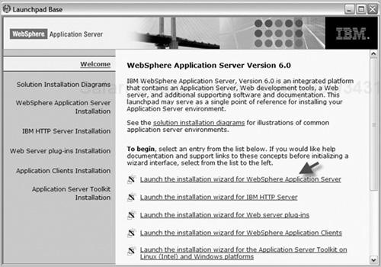

**Figure 3-6. WebSphere Application Server V6 welcome panel**

Read through the contents of the welcome panel, and then select the option to “Launch the installation wizard for WebSphere Application Server.” (If you’re using the Express package, you may need to choose the option “WebSphere Application Server – Express Installation” on the task menu to the left of the welcome text.) Click **Next**.

1. On the next panel, click to accept the terms of the license agreement, and then click **Next**.
2. The next panel informs you that the installation program is checking system prerequisites. If the wizard reports that the check was successful, click **Next**. If the prerequisites check fails, cancel the installation program, and open and read the log file that was generated during the check (file log.txt in the TMP directory). Correct your system to meet the requirements, and then run the installation program again. For more information about logging and troubleshooting, see “[Logging: Problem Determination and Troubleshooting](https://www.safaribooksonline.com/library/view/websphere-application-server/9781583470619/ch03.html#ch03lev1sec7).”

If the wizard detects an existing WebSphere installation (Version 5 or 6) when it runs the prerequisites check, an informational panel informs you that you’ll need to assign unique port values for each installation. Read through the details on this panel, and then click **Next**. (If no other version of WebSphere exists on the machine, you won’t see this panel.)

### **Note**

The sequence of panels hereafter depends on various conditions, such as whether there’s an existing WebSphere installation on the machine you’re installing (and which features were installed previously).

1. You use the next panel ([Figure 3-7](https://www.safaribooksonline.com/library/view/websphere-application-server/9781583470619/ch03.html#ch03fig07)) to specify the installation directory for the application server — that is, the <WASV6-ROOT> directory. You can accept the default directory or specify a different location. If you’re using the Windows operating system, make sure the directory name you use contains no spaces (even though the install program and Windows permit spaces in path names). For the sample installation described here, we used C:\IBM\ WebSphere\AppServer as the application server installation directory.

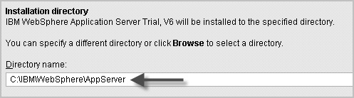

**Figure 3-7. Specifying the installation directory**

After specifying your installation directory, click **Next**.

1. On the next panel ([Figure 3-8](https://www.safaribooksonline.com/library/view/websphere-application-server/9781583470619/ch03.html#ch03fig08)), select **Custom installation**, and click **Next**. (This panel won’t appear if you have an existing installation of WebSphere V6 on this machine.)

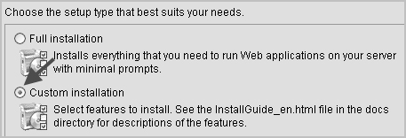

**Figure 3-8. Choosing a custom installation**

1. When you choose the custom install option, the wizard lets you specify which WebSphere features you want to install. If you’re performing this installation for educational or training purposes, select the **Application Server Samples** check box (shown in [Figure 3-9](https://www.safaribooksonline.com/library/view/websphere-application-server/9781583470619/ch03.html#ch03fig09)) in addition to the preselected options the wizard presents. These sample applications demonstrate the functionality of the application server.

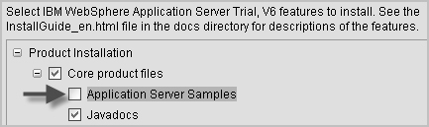

**Figure 3-9. Application Server Samples option**

For production and test environments, we recommend you don’t install the Application Server Samples. You can add them later if you like by upgrading the installation (a process we cover in[Chapter 4](https://www.safaribooksonline.com/library/view/websphere-application-server/9781583470619/ch04.html)). Note that the default application (DefaultApplication), which you’ll use later to verify the basic operation of the application server, will be installed even if you choose not to install the Application Server Samples.

When you’ve made your selection, click **Next** to proceed with the installation.

1. The installation wizard next gives you a chance to change the default port numbers. [Figure 3-10](https://www.safaribooksonline.com/library/view/websphere-application-server/9781583470619/ch03.html#ch03fig10)shows the port number display. If the installation program detected an existing instance of WebSphere Application Server V6, each port number that appears on this panel will be incremented by 1, starting with the port number of the last instance.

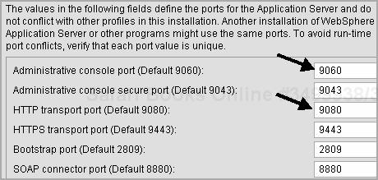

**Figure 3-10. Application server ports**

### **Note**

The install program keeps track of existing instances, their port numbers, and other features using the file vpd.properties. Each time you install WebSphere product binaries and/or create a new profile using the existing product binaries and the Profile Creation wizard (covered later), the program creates an entry in this file and automatically decides the default port numbers for the new profile.

The IBM support team may ask you to edit the properties file if you have problems uninstalling and/or reinstalling WebSphere. Never change this file unless IBM support asks you to do so. The file’s location varies according to operating system:

* + For Windows, the location is C:\Windows.
  + For Windows NT, the location is C:\WINNT.
  + For AIX, the location is /usr/lib/objrepos.
  + For Linux, the location is root directory ‘/’.

At the time of this writing, HP-UX and Solaris don’t use the vpd.properties file.

Here’s a brief description of the ports and their use:

* + **Administrative console port – 9060 —.**You use this port in the browser URL when you want to connect to the application server from the admin console (e.g., http://was-host:9060/ibm/console). If you’ve configured the node for Secure Sockets Layer (SSL), you use the secure port (9043) instead of 9060.
  + **HTTP transport port – 9080 —.**You use this port when you want to invoke a Web application running on the application server from a browser. For example, to invoke the snoop servlet, you’d use http://was-host:9080/snoop. If you’ve configured the node for SSL, you use the secure port (9443) instead of 9080.
  + **Bootstrap port – 2809 —.**Client applications use the bootstrap port to access WebSphere’s built-in Object Request Broker (ORB) to use Enterprise Java Beans (EJBs) in applications installed on the application server. The Java Naming and Directory Interface (JNDI) service provider URL used by the client application needs to reference the bootstrap port to obtain an initial context for looking up EJBs it wants to use.
  + **SOAP connector port – 8880 —.**Client applications (e.g., wsadmin) use the Simple Object Access Protocol (SOAP) port to connect to the application server admin service. Also, when you federate a node from the Deployment Manager’s admin console, you must specify the application server host name and its SOAP port (8880 in this example).

After making any port number changes required for your environment, click **Next**.

1. You use the wizard’s next panel ([Figure 3-11](https://www.safaribooksonline.com/library/view/websphere-application-server/9781583470619/ch03.html#ch03fig11)) to specify the node and host names for the application server. To accept the default names, simply click **Next**.

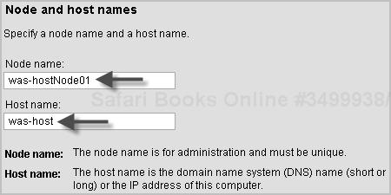

**Figure 3-11. Specifying the node name and host name**

If you want to change the default node name, make sure the name you choose is unique among

* + multiple application server profiles on the same node per installation
  + nodes in a Network Deployment domain

Also, avoid using the following reserved words: cells, nodes, servers, clusters, applications, anddeployments.

The host name can be the fully qualified host name (e.g., was-host.noyb.com), the host name (e.g., was-host), or the IP address (e.g., 24.142.101.52) of the machine. Use the following criteria when deciding which option to use:

* + Use the fully qualified name in production systems and/or where multiple network interface cards (NICs) exist at the time of WebSphere installation or when you may be upgrading the machine with multiple NIC cards in the future.
  + Use the host name where a single NIC card exists at WebSphere installation and you’re certain the machine won’t have multiple cards in the future.
  + We don’t recommend using the IP address unless you have a valid reason to do so.

Note that the installation program doesn’t validate the host name during the installation. If you specify an invalid host name or Domain Name Server (DNS) entry, you’ll receive an exception (InvocationTargetException) when starting the application server after installation. For more information about this error, see “[Logging: Problem Determination and Troubleshooting](https://www.safaribooksonline.com/library/view/websphere-application-server/9781583470619/ch03.html#ch03lev1sec7).”

1. If you want to use a Windows service to run WebSphere Application Server, choose the option to “Run the application server process as a Windows service” on the next panel ([Figure 3-12](https://www.safaribooksonline.com/library/view/websphere-application-server/9781583470619/ch03.html#ch03fig12)). (You won’t see this panel on non-Windows operating systems.)

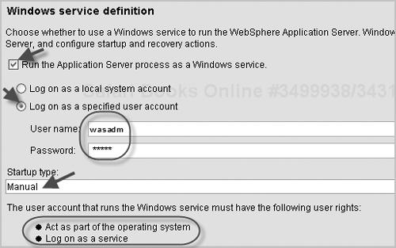

**Figure 3-12. Specifying the Windows service startup type**

If you don’t select the Windows service option, the installation program disregards any values entered below it on this panel. If you choose the option and select the option to “Log on as a local system account,” a user name and password are optional. If you choose the Windows service option and select “Log on as a specified user account,” you must provide a valid user name (with no spaces) and password. This user should have “Log on as a service” authority to run the process.

If you choose the Windows service option, you must also specify a Windows service startup type (Automatic, Manual, or Disabled). When you’re finished with this panel, click **Next**.

1. The wizard next displays a preinstallation summary panel. Review the information on the panel, and click **Next** to proceed with the installation. You’ll see a progress panel while the installation program extracts files and installs components.

You’ll notice that the installation program creates the installation directory (<WASV6-ROOT>) at this stage and starts logging information under the subdirectory <WASV6-ROOT>\logs. For information about this logging, see “[Logging: Problem Determination and Troubleshooting](https://www.safaribooksonline.com/library/view/websphere-application-server/9781583470619/ch03.html#ch03lev1sec7).”

1. When a panel reporting a successful installation appears, select the “Launch the First Steps Console” option, and click **Finish**. You’ll use the First Steps tool later to verify your WebSphere Application Server installation.
2. After installing any WebSphere component, you should check for and apply the latest fixes. [Chapter 19](https://www.safaribooksonline.com/library/view/websphere-application-server/9781583470619/ch19.html) describes how to install product updates for the different WebSphere components when a refresh pack or fix pack is available to install. Consult that chapter for the steps to perform for this installation, and then return to this chapter for instructions on verification and problem determination.

# Understanding the WebSphere Standalone Application Server Directory Structure

The WebSphere installation process creates several important directories under the installation root <WASV6-ROOT> (directory C:\IBM\WebSphere\AppServer in our example). [Figure 3-13](https://www.safaribooksonline.com/library/view/websphere-application-server/9781583470619/ch03.html#ch03fig13) depicts the directory structure of the application server profile that’s created using the WebSphere Base/Express package.

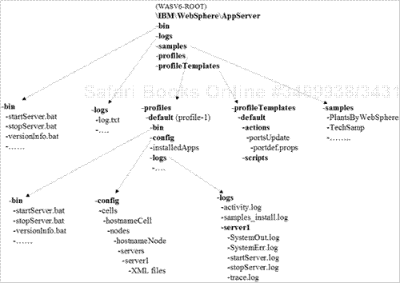

**Figure 3-13. Directory structure of the application server profile**

Here’s a brief look at the purpose of each directory.

* **bin —.**The bin directory contains all the executable commands needed to manage and configure a WebSphere application server.
* **logs —.**Files under the logs directory are created during the WebSphere installation. For more information about this directory, see “[Logging: Problem Determination and Troubleshooting](https://www.safaribooksonline.com/library/view/websphere-application-server/9781583470619/ch03.html#ch03lev1sec7).”
* **profiles —.**Each profile you create is stored under the profiles directory by default. The installation program creates a profile called default (and an application server, server1, within it) during the WebSphere V6 Base/Express installation. Each profile directory (e.g., default) contains the files (specific to that profile) that are required to run and manage the application server within that profile. When creating a profile using the Profile Creation wizard or the wasprofile command, you can choose a different destination that needn’t be under the profiles directory.
* **profileTemplates —.**This directory houses the profile templates used to define the configuration settings of new servers you create. The Base/Express package comes with the default profile, which the Profile Creation wizard uses when it creates a new application server profile.
* **samples —.**Source and binary files for all the WebSphere samples are available under this directory.
* **_uninst —.**This directory contains the uninstall execution program and related files that are used if you uninstall the WebSphere product.

[Figure 3-14](https://www.safaribooksonline.com/library/view/websphere-application-server/9781583470619/ch03.html#ch03fig14) provides a complete view of the structure of the default profile after the WebSphere Base/Express installation.

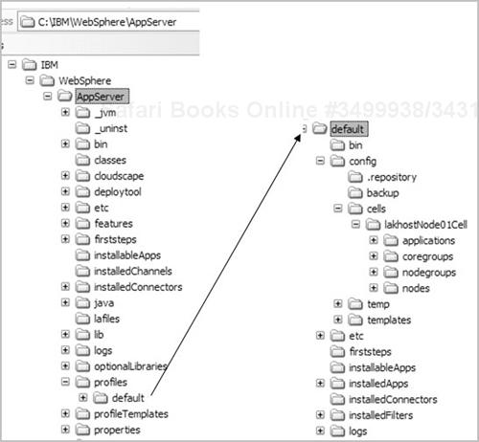

**Figure 3-14. Directory structure of the default profile**

# Verifying the Standalone Application Server Installation

Even though the final panel of the installation wizard reported that your WebSphere installation took place successfully, it’s important to verify the installation by performing a few simple checks. This way, you’ll know which log files to refer to or what to verify if a problem occurs. In this section, we show you how to confirm a successful installation using the following tools:

* log files
* the First Steps console
* the administrative console
* the default application (snoop, hello, and hitcount)

We also explain how to verify that the application server process is running as a Windows service (for Windows users who choose to configure WebSphere this way).

## Verify Installation by Viewing the Log Files

To confirm a successful installation of the standalone application server using the installation log files, go to the <WASV6-ROOT>\logs directory and open the file named log.txt. Scroll to the end of the file. If you see the indicator INSTCONFSUCCESS (as shown in [Figure 3-15](https://www.safaribooksonline.com/library/view/websphere-application-server/9781583470619/ch03.html#ch03fig15)), the installation may indeed have succeeded. You need to verify a few more things (as we’ll explain in a moment) before you can claim that the installation is successful.

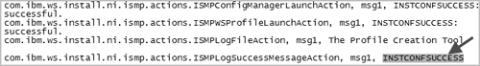

**Figure 3-15. Verifying a successful installation**

If you see either INSTCONFFAIL or INSTCONFPARTIALSUCCESS, the installation program encountered problems. To determine the source of the trouble, consult this chapter’s “[Logging: Problem Determination and Troubleshooting](https://www.safaribooksonline.com/library/view/websphere-application-server/9781583470619/ch03.html#ch03lev1sec7)” section.

As we explained at the beginning of the installation section, a default profile (and an application server, server1) is created as part of the installation process (in Phase 2). As part of verifying the installation, you should confirm the successful creation of the default profile. To do so, go to the <WASV6-ROOT>\logs\wasprofile directory, open the file wasprofile_create_default.log, and scroll to the end of the file. If you see the INSTCONFSUCCESS indicator (as shown in [Figure 3-16](https://www.safaribooksonline.com/library/view/websphere-application-server/9781583470619/ch03.html#ch03fig16)), the installation succeeded. If you see errors in the file, consult “[Logging: Problem Determination and Troubleshooting](https://www.safaribooksonline.com/library/view/websphere-application-server/9781583470619/ch03.html#ch03lev1sec7).”

Verifying creation of the default profile

**Figure 3-16. Verifying creation of the default profile**

## Verify Installation Using the First Steps Console

When you select the final installation panel’s option to launch the First Steps console, the First Steps program is started immediately after the WebSphere installation is completed. If you perform a silent installation (a process we describe in [Chapter 4](https://www.safaribooksonline.com/library/view/websphere-application-server/9781583470619/ch04.html)), you must start this program manually. You can launch First Steps at any time by clicking the Windows **Start** button and navigating to **All programs|IBM WebSphere|Application Server v6|Profiles|default|First steps**. You can also invoke the program by opening a command window and running **firststeps.bat** from the directory <PROFILE-ROOT>\firststeps (where <PROFILE-ROOT> = <WASV6-ROOT\profiles\default).

When the First Steps program begins, it displays the First Steps wizard. This useful tool lets WebSphere administrators perform the following tasks from one screen:

* Verify the installation.
* Start or stop the application server.
* Connect to the admin console.
* Start the Profile Creation wizard.
* Invoke and work with the sample applications.
* Connect to the WebSphere Information Center.
* Invoke the migration wizard.

To confirm a successful WebSphere installation, click the panel’s **Installation verification** option. (You can also run the installation verification program, ivt.bat, at the command prompt from the <PROFILE-ROOT>\bin directory.) If the installation was successful, you should see a notification screen similar to the one shown in [Figure 3-17](https://www.safaribooksonline.com/library/view/websphere-application-server/9781583470619/ch03.html#ch03fig17).

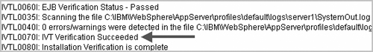

**Figure 3-17. First Steps verification of a successful installation**

If the default application server hasn’t been started, the verification program starts it. Review the notification messages to ensure that the server process has been started. Also, make sure that the next-to-last line in the log indicates “IVT Verification Succeeded.” If the installation verification wasn’t successful, review “[Logging: Problem Determination and Troubleshooting](https://www.safaribooksonline.com/library/view/websphere-application-server/9781583470619/ch03.html#ch03lev1sec7).”

## Connect to the Application Server Through the Admin Console and Verify

To connect to the application server through the WebSphere Application Server administrative console, click **Administrative Console** on the First Steps main panel. For the user ID, enter any value (including blank, although we don’t suggest it). WebSphere won’t check against any user registry to authenticate unless security is turned on and configured; nevertheless, it’s a good idea to enter a meaningful user name to enable logging and recovery of any configuration information changed using that particular user ID. WebSphere stores the activity log under the <PROFILE-ROOT>\wstemp directory.

Click **Log in** (or press Enter) to connect to the admin console and display the welcome panel ([Figure 3-18](https://www.safaribooksonline.com/library/view/websphere-application-server/9781583470619/ch03.html#ch03fig18)). (You can also invoke the admin console from a browser using the URL http://was-host:port/ibm/console, where port is the port number of the admin console — 9060 by default.) The welcome panel offers some useful information and links (e.g., to WebSphere Support, IBM DeveloperWorks, and Documentation) and provides the WebSphere product version, build number, and build date.

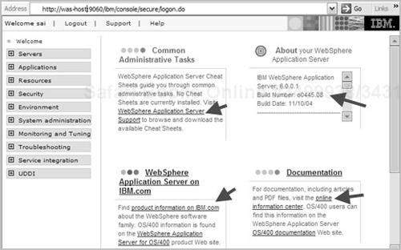

**Figure 3-18. WebSphere admin console welcome panel**

To see the default application server that was created during the installation, expand the **Servers** item in the left pane, and click **Application Servers**. You’ll see the default application server, server1, displayed on the right ([Figure 3-19](https://www.safaribooksonline.com/library/view/websphere-application-server/9781583470619/ch03.html#ch03fig19)).

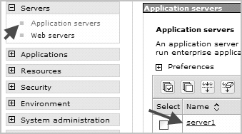

**Figure 3-19. Default application server in admin console**

To see the applications that have been deployed, expand **Applications** and click **Enterprise Applications**. The list of installed applications appears on the right ([Figure 3-20](https://www.safaribooksonline.com/library/view/websphere-application-server/9781583470619/ch03.html#ch03fig20)). (If you didn’t select the Application Server Samples option during installation, you won’t see PlantsByWebSphere and SamplesGallery in the list.) Make sure each application is shown as running (indicted by a green arrow in the Status column). If any application is stopped, there may be a problem with the installation. For troubleshooting information, see “[Logging: Problem Determination and Troubleshooting](https://www.safaribooksonline.com/library/view/websphere-application-server/9781583470619/ch03.html#ch03lev1sec7).”

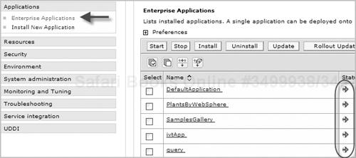

**Figure 3-20. Enterprise applications**

## Verify Installation from the Browser Using the Default Application

Every administrator should understand how to use the three programs in WebSphere’s DefaultApplication sample application — snoop, hello, and hitcount — to verify the application server configuration. Let’s walk through the steps involved.

### **Snoop**

The snoop servlet verifies the connection between the browser and the application server’s Web container (through the Embedded HTTP Server). To invoke the snoop program, open the browser and enter **http://was-host:port/snoop** (where port is the HTTP transport port — 9080 by default). You should see a screen similar to the one shown in [Figure 3-21](https://www.safaribooksonline.com/library/view/websphere-application-server/9781583470619/ch03.html#ch03fig21). Scroll down the page, and navigate through the output to see the detailed information reported for the servlet request.

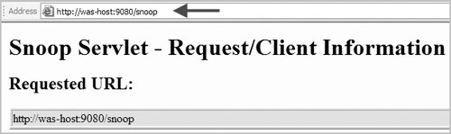

**Figure 3-21. Snoop servlet**

### **Hello**

The hello servlet is designed with client type-detection support. You can invoke this servlet from a browser, a speech client, or a Wireless Access Protocol–enabled browser, for example. To invoke the servlet from a browser, enter **http://was-host:port/hello**. You should see a screen similar to the one shown in [Figure 3-22](https://www.safaribooksonline.com/library/view/websphere-application-server/9781583470619/ch03.html#ch03fig22).

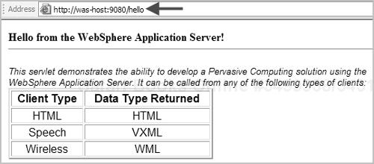

**Figure 3-22. Hello servlet**

### **Hitcount**

The hitcount servlet demonstrates how to increment a counter value using several different methods. To invoke the servlet, enter **http://was-host:port/hitcount** after opening the browser. You should see a page similar to the one shown in [Figure 3-23](https://www.safaribooksonline.com/library/view/websphere-application-server/9781583470619/ch03.html#ch03fig23).

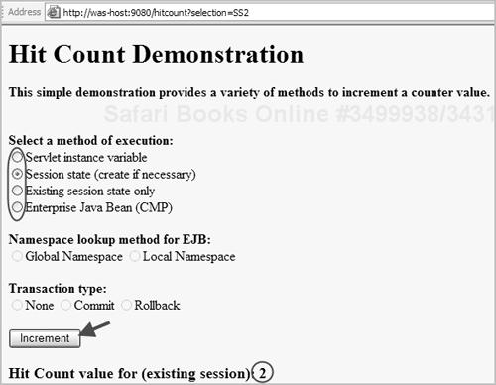

**Figure 3-23. Hitcount servlet**

This page offers several ways to increment a counter value:

* Select the “Servlet instance variable” option and click the **Increment** button a few times to see the hit count value for the existing session being incremented. We use this option to verify the health of the Web container.
* Select the “Session state (create if necessary)” option and click **Increment** a few times to verify that a session is created and the hit count value (attached to the session) is incremented.
* Select the “Existing session state only” option and click **Increment** a few times to see that the hit count value is incremented to the value stored in the existing session. (You’ll use this option in a later chapter to verify the session persistence configuration after configuring a cluster.)
* Select the “Enterprise Java Bean (CMP)” option and click **Increment** a few times to see the hit count value incremented. This option helps you identify the connection between
  + browser and Web container (through the Embedded HTTP Server)
  + Web container and EJB container
  + EJB container and the database (Cloudscape in this case)

You can use this option with the page’s “Namespace lookup method for EJB” options to verify the global and local name spaces of the EJB. You can use it with the “Transaction Type” options to verify commit and rollback through the EJB.

## Verify the Windows Services Panel for the Application Server Process

If you chose the option to “Run the application server process as Windows service” during the WebSphere installation (Windows platforms only), take the following steps to confirm this configuration. Click **Start** and navigate to **Control Panel|Administrative Tools|Services** to open the Windows **Services** panel. You should see IBM WebSphere Application Server V6 listed as a service with a status of Started.

If you forgot to select (or cleared) the Windows service check box during the installation and want to register WebSphere as a service now, follow the instructions in [Chapter 20](https://www.safaribooksonline.com/library/view/websphere-application-server/9781583470619/ch20.html) to register the application server process in the Windows service registry.

# Configuring the Service Integration Bus and Enabling the Messaging Engine

Unlike previous versions of WebSphere, the WebSphere V6 Java Message Service (JMS) provider runs in an application server process (JVM). When you install the standalone application server or create a new profile, the V6 messaging engine (ME) isn’t enabled by default. However, the product binaries required to enable the ME are copied to the installation directory during the product installation itself.

You don’t have to configure a Service Integration Bus (SIBus) or an ME if the applications installed on the application server aren’t using JMS. If your application is using JMS and/or message-driven EJBs, you need to perform the steps outlined in this section.

To enable a messaging engine, you must complete two tasks:

* Create and configure an SIBus.
* Include the application server as a member of the SIBus to create and enable the messaging engine inside the application server (JVM).

[Figure 3-24](https://www.safaribooksonline.com/library/view/websphere-application-server/9781583470619/ch03.html#ch03fig24) illustrates the WebSphere V6 ME architecture. [Chapter 12](https://www.safaribooksonline.com/library/view/websphere-application-server/9781583470619/ch12.html) provides a detailed explanation of the SIBus and the ME. When following the instructions in that chapter, add a standalone application server (instead of a cluster) as a member of the bus (as shown in [Figure 3-25](https://www.safaribooksonline.com/library/view/websphere-application-server/9781583470619/ch03.html#ch03fig25)). When doing so, you have option to use a data source that points to a production-quality database or the default data source, which uses the built-in Cloudscape database to store persistent messages.

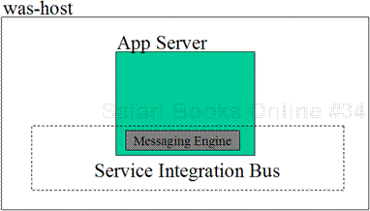

**Figure 3-24. WebSphere V6 messaging engine architecture**

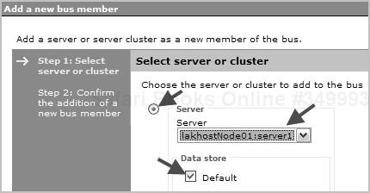

**Figure 3-25. Adding a new bus member**

# Creating Multiple Application Server Profiles

As you learned in [Chapter 1](https://www.safaribooksonline.com/library/view/websphere-application-server/9781583470619/ch01.html), you can use the same set of product binaries and the default application server template to create multiple application server profiles. WebSphere will deploy the administrative console and default applications (as well as the samples if you choose) on each profile you create, making it easier to manage multiple application server profiles. The diagram in [Figure 3-26](https://www.safaribooksonline.com/library/view/websphere-application-server/9781583470619/ch03.html#ch03fig26)depicts a system on which a second application server profile has been created. The new instance accepts requests for the admin console and installed applications at port 9061 and 9081, respectively.

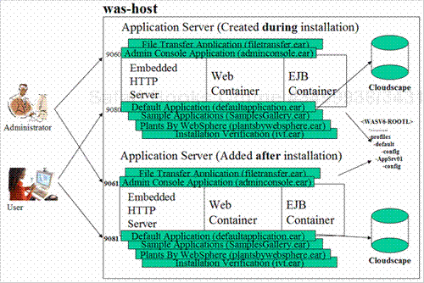

**Figure 3-26. Multiprofile application server architecture**

1. WebSphere offers multiple methods for creating an additional application server profile. You can launch the Profile Creation wizard by clicking the **Start** button and selecting **All Programs|IBM WebSphere|Application Server v6|Profile creation wizard**. You can also invoke the Profile Creation wizard from the First Steps wizard by running **firststeps.bat** from the command prompt under the <PROFILE-ROOT>\firststeps directory. A third way to start the profile-creation tool is to run **pctWindows.exe** under the <WASV6-ROOT>\bin\ProfileCreator directory.

### **Note**

On AIX, the profile-creation executable is named pctAIX.bin. On Linux, it is pctLinux.bin. Look for the required executable in directory <WASV6-ROOT>/bin/Profile Creator.

If you want to create a new profile from the command prompt, go to the <WASV6-ROOT>\bin directory and run the command **wasprofile -create -help** first to see the arguments required to create a profile from the command line.

1. The Profile Creation wizard first asks you to give the new profile a name ([Figure 3-27](https://www.safaribooksonline.com/library/view/websphere-application-server/9781583470619/ch03.html#ch03fig27)). If you want to change the default name displayed by the wizard (AppSrv01), make sure the name you specify is unique among

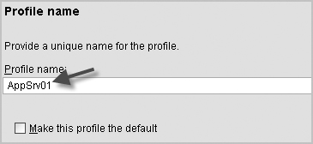

**Figure 3-27. Profile name panel**

* + multiple application server profiles on the same node per installation
  + nodes in a Network Deployment domain

The profile name panel also offers you the option to “Make this profile the default.” In a multiprofile environment, you can use this option to specify one of the profiles as a default profile. You already have a profile named ‘default’ that was created during installation of the Base/Express package, and at this point that profile is the default profile.

It’s important to understand how the default profile differs from other profiles. When you choose a profile as the default profile, you don’t have to specify the –profileName argument when running any command from the <WASV6-ROOT>\bin directory. For example, to start the default profile, you can just issue

startServer server1

For all other profiles, you must specify the profile name. For example:

startServer server1 –profileName AppSrv01

In addition, during plug-in installation, the default profile configuration is updated with the Web server definition when you run the configure webserver.bat program. If you plan to configure the profile you’re creating (AppSrv01 in our example) with HTTP Server through the plug-in, you should select the option to “Make this profile the default.” You’ll learn more about the plug-in installation in [Chapter 6](https://www.safaribooksonline.com/library/view/websphere-application-server/9781583470619/ch06.html).

In summary, you should make your new profile the default profile if it will be the most frequently used profile and/or if it is the profile you want to configure with the Web server definition later. For our example, simply leave this option unchecked, and click **Next**.

1. On the next panel, enter the directory where the new profile configuration should be created (or accept the default directory). (Throughout the book, we refer to this new profile root directory as <NEW-PROFILE-ROOT>.) Click **Next**.
2. Next, you must specify the node and host names for the new profile. To accept the default names, simply click **Next**. If you want to change the default node name, make sure the name is unique among
   * multiple application server profiles on the same node per installation
   * nodes in a Network Deployment domain

Also, avoid using the reserved names cells, nodes, servers, clusters, applications, and deployments.

The host name can be the DNS entry or the host name of the machine. (You can also use the raw IP address for the host name, but we don’t advise doing so.)

1. Next, the Profile Creation wizard displays the assigned port numbers for the new instance ([Figure 3-28](https://www.safaribooksonline.com/library/view/websphere-application-server/9781583470619/ch03.html#ch03fig28)). The wizard program automatically increments the port numbers by 1 from the port numbers of the last installed instance of WebSphere V6. To open the admin console for the new instance, for example, you’ll use the URL http://was-host:**9061**/ibm/console. To invoke the snoop servlet, you’ll use http://was-host:**9081**/snoop.

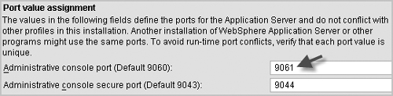

**Figure 3-28. Port value assignment**

Review the assigned ports, and click **Next**.

1. On the next panel, select the check box option and choose a Windows service startup type if you want to run the application server process as a Windows service. Click **Next**.
2. Review the summary panel, and click **Next** to create the new profile.
3. On the panel indicating successful creation, select the option to “Launch the First steps Console,” and then click **Finish**.
4. To verify the creation of your new application server profile, follow the instructions given above for verification using the First Steps console. Substitute <NEW-PROFILE-ROOT> for <PROFILE-ROOT> when following these steps.
5. If you selected to run the application server process as a Windows service, open the **Services** panel using **Start|Control Panel|Administrative Tools|Services**, and look for the new WebSphere process.

## The Multiple Application Server Profile Directory Structure

[Figure 3-29](https://www.safaribooksonline.com/library/view/websphere-application-server/9781583470619/ch03.html#ch03fig29) shows the complete view of the WebSphere V6 multiprofile directory structure. As you can see, each application server profile uses the same binary files and has a dedicated directory (default and AppSrv01 in this case) where the items specific to that profile (its configuration, applications, log files, and so on) are stored, making it easier for the administrator to manage.

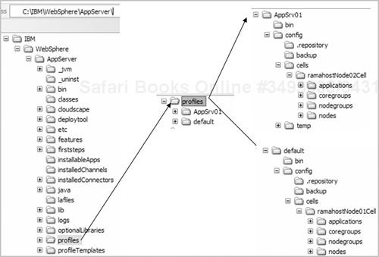

**Figure 3-29. Multiprofile directory structure**

# Logging: Problem Determination and Troubleshooting

WebSphere Application Server V6 automatically logs all activities by default. Log files are your main source of information for diagnosing problems that occur during installation, profile creation, and server management. The location (directory) of the log files varies depending on the activity. For example, the logs generated during installation are stored in a different place than those generated when you manage (e.g., start, stop) an application server. Each activity creates logging information in one or more log files.

In this section, we describe how logging takes place, from product installation through the various stages of managing the application server. The illustration in [Figure 3-30](https://www.safaribooksonline.com/library/view/websphere-application-server/9781583470619/ch03.html#ch03fig30) depicts the logging architecture for the WebSphere V6 standalone application server.

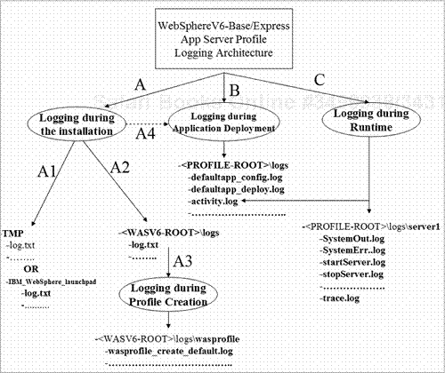

**Figure 3-30. WebSphere V6 logging architecture**

You can logically divide the destination of the log files into seven categories according to the activity performed on the application server. [Table 3-2](https://www.safaribooksonline.com/library/view/websphere-application-server/9781583470619/ch03.html#ch03table02) provides a guide to these categories. In addition to the log files specified in the table, the log files activity.log and trace.log aid in problem determination. For more information about these two files, see [Chapter 22](https://www.safaribooksonline.com/library/view/websphere-application-server/9781583470619/ch22.html).

**Table 3-2. WebSphere logging categories**

| **Activity** | **log destination** | **Description** | **When to use these files** |
| --- | --- | --- | --- |
| Installation — initial part | The TMP directory   * File log.txt is the important log file under this destination. * If you used the Launchpad program to start the installation, you’ll see the log files under the TMP directory’s IBM_WebSphere_launchpad subdirectory. * If you used install.exe to perform the installation, the log files are created immediately under directory TMP. * On Windows, check the TMP environment variable to determine the value of the temporary directory. The examples in this chapter use C:\temp as the TMP value on the Windows machine. * On Unix, /tmp is usually the temporary directory. | These log files are populated immediately after invocation of the Launchpad or install.exe program. After a successful installation, the files are copied to the logs subdirectory under the installation directory (<WASV6-ROOT>). | * Use if you have a problem starting the Launchpad or install.exe or encounter problems during the early part of the installation. * Use if the system prerequisites check fails and you want to see the reason. |
| Installation — later part Profile creation or deletion Application deployment | The <WASV6-ROOT>\logs directory specified during installation   * File log.txt is the important log file under this destination. | These log files are populated from the moment you click **Next**after reviewing the summary report during the graphical installation. | * Use if the installation wasn’t successful and you want to know why. * If these log files don’t provide enough information, consult the log files under the TMP directory. |
| Profile creation or deletion | The <WASV6-ROOT>\logs\wasprofile directory   * File names created are as follows:   + wasprofile_create_profileNa me.log and   + wasprofile_delete_profileNa me.log. * If you use the Profile Creation wizard to create a profile, all the events are logged in file pctLog.txt under the <NEW-PROFILE-ROOT>\logs directory | Log files under this directory are populated when you use the Profile Creation wizard or the wasprofile command-line tool. If you’re using the Base or Express package, creation of the ‘default’ profile is part of the installation. | * Use if you have problems creating or deleting a profile or if installation isn’t successful. |
| Application deployment | The <PROFILE-ROOT>\logs directory   * The log files for the applications deployed on the default profile during the sample installation were created under the C:\IBM\WebSphere\profiles\default\logs directory. | For each application installed, you’ll see two log files:   * <appname>_deploy.txt and * <appname>_config.txt. | * Use if you have a problem invoking the default application (snoop, hello, and hitcount) or any of the sample applications after installation. * Use if you have a problem deploying user applications or invoking them after deployment. |
| Application server management (e.g., starting/stopping the server, checking the server status) | The <PROFILE-ROOT>\logs\server1 directory | You can see one log file for each initiated command. For example, if you run the command**startServer server1**, you’ll see the startServer.log file under its log destination. | * Use if execution of the command fails. |
| Application server JVM logging | The <PROFILE-ROOT>\logs\server1 directory   * The log files are SystemOut.log and SystemErr.log. | Messages sent to the JVM stdout and stderr streams are directed to the SystemOut.log file and the SystemErr.log file, respectively. SystemOut.log is one of the most widely used log files for problem determination and troubleshooting. | * Use for problems that occur during application server startup, shutdown, or runtime. |
| Native process logging | The <PROFILE-ROOT>\logs\server1 directory   * The log files are native_std-out.log and native_stderr.log. | Messages sent to stdout and stderr from native code segments are directed to the native_stdout.log file and the native_stderr.log file, respectively. | * Use for problems that occur in native code or code written using the Java Native Interface (JNI). Verbose GC (garbage collection) output goes to the native stderr log for IBM JDKs. |

## Accessing Log Files from the Admin Console

When you’re performing WebSphere problem determination and troubleshooting, it’s handy to be able to view the log files from the admin console using a browser instead of physically logging into the machine and accessing individual files. The following steps explain how to view the JVM log files SystemOut.log and SystemErr.log from the admin console. File SystemOut.log is one of the most widely used log files for problem determination and troubleshooting.

1. Connect to the admin console, and expand **Troubleshooting|Logs and Trace|server1**. You’ll see a list of the different groups of logs you can view from the console ([Figure 3-31](https://www.safaribooksonline.com/library/view/websphere-application-server/9781583470619/ch03.html#ch03fig31)).

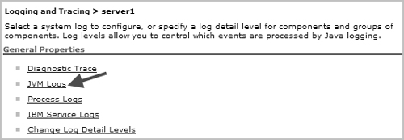

**Figure 3-31. Log file groups in admin console**

1. Click **JVM Logs**, and select the **Runtime** tab to see the JVM log files ([Figure 3-32](https://www.safaribooksonline.com/library/view/websphere-application-server/9781583470619/ch03.html#ch03fig32)).

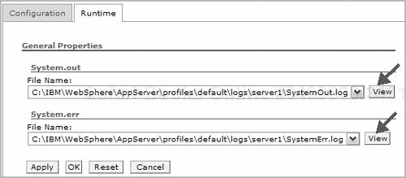

**Figure 3-32. JVM log file display**

1. Use the drop-down list to select the log file you want to see, and click **View**.
2. The resulting screen ([Figure 3-33](https://www.safaribooksonline.com/library/view/websphere-application-server/9781583470619/ch03.html#ch03fig33)) reports the total number of lines in the selected file (454 in this case) and displays the first 250 of them. Enter the line number range you want to view in the**Retrieve Lines** box, and click **Refresh**. For example, to see from line 350 to the end of the sample file, you’d enter “350-454” as shown in the figure.

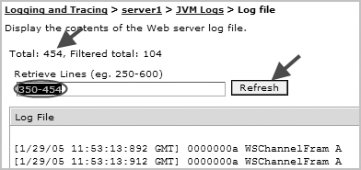

**Figure 3-33. Sample log file display**

## Problem Scenarios

Now that you’ve seen how to check the log files, let’s consider some common problems encountered during installation and verification of the standalone application server and explain their solutions.

Problem: You’re unable to start the installation wizard; installation fails, and no log files are created, even under the TMP directory.

The most likely cause of this problem is a lack of minimum disk space (1,030 MB). If you have enough disk space and still experience the problem, run the installation in silent mode, using the following command to produce the log file:

install –options "path to response file" -silent –log # !C:\temp\log.txt

@ALL

(For complete instructions on performing a silent install, see [Chapter 4](https://www.safaribooksonline.com/library/view/websphere-application-server/9781583470619/ch04.html).)

### **Unix note**

On Unix systems, use this command: /install –options “path to response file” -silent –log # !/tmp/log.txt @ALL

Problem: Installation verification (IVT) shows that installation wasn’t successful. Take the following steps to diagnose this problem.

1. Check the file ivtClient.log under the <PROFILE-ROOT>\logs directory. Because the IVT program starts the application server, also look for errors in the SystemOut.log file under the <PROFILE-ROOT\logs\server1 directory.
2. Open the file log.txt under the <WASV6-ROOT>\logs directory. If you see the INSTCONFFAIL or INSTCONFPARTIALSUCCESS indicator, a problem occurred during product installation (copying of the product binaries). Look for the cause of the failure in this file.
3. Open the file wasprofile_create_profileName.log under the <WASV6-ROOT>\logs\wasprofile directory. If you see INSTCONFFAIL or INSTCONFPARTIALSUCCESS, a problem occurred during creation of the default profile. Look for the cause of the failure in this file.

Problem: You encounter a problem invoking the default application (snoop, hello, and hitcount) from the browser.

Take the following steps to diagnose this problem.

1. Check the log files that were created while deploying the default application during installation: files defaultapp_deploy.log and defaultapp_config.log under the <PROFILE-ROOT>\logs directory.
2. Make sure the application server was started successfully. Open SystemOut.log, and look for the message “Server server1 open for e-business” at the end. If this message is absent, look for the errors to determine the cause of the problem.
3. Verify that the port you’re using for Web applications is correct. (The default port is 9080. To invoke the snoop servlet deployed on the default application server using the default port, use http://was-host:**9080**/snoop.) Remember that in WebSphere you can have multiple application server profiles using the same product binaries. The port numbers for each profile are unique on the same node. Make sure you’re connecting to the right profile.
4. If you’re unsure which port you’re using to invoke Web applications, open SystemOut.log, and look for a line similar to this: “Web Module Default Web Application has been bound to default_host[*:**9080**,*:80,*:9443]”.

If you see some other port number instead of 9080, invoke the application using that port.

1. If the preceding method doesn’t work, look for the endpoint (port) for the WC_defaulthost in file serverindex.xml under the <PROFILE-ROOT>\config\cells\yourCell\nodes\y ourNode directory, and use that port instead. ([Figure 3-34](https://www.safaribooksonline.com/library/view/websphere-application-server/9781583470619/ch03.html#ch03fig34) shows a sample endpoint entry.) Be sure not to change any information in this file.

Sample endpoint entry

**Figure 3-34. Sample endpoint entry**

1. If you’re trying to connect through a Web browser from a remote machine, make sure you can ping the machines from each other using IP address, host name, and fully qualified name (DNS entry).

Problem: You have trouble connecting to the admin console.

Take the following steps to diagnose this problem.

1. Make sure the application server was started successfully. Open SystemOut.log, and look for the message “Server server1 open for e-business” at the end. If this message is absent, look for the errors to determine the cause of the problem.
2. Verify that the port you’re using for the admin console is correct. (The default port is 9060. To invoke the admin console that was deployed on the default application server using the default port, use http://was-host:**9060**/ibm/console.) Remember that in WebSphere you can have multiple application server profiles using the same product binaries. The port numbers for each profile are unique. Make sure you’re connecting to the right profile.
3. If you’re unsure which port you’re using to invoke the admin application, open SystemOut.log, and look for a line similar to this: “Web Module adminconsole has been bound to admin_host[*:**9060**,*:9043].” If you see some other port number instead of 9060, invoke the admin application using that port.
4. If the preceding method doesn’t work, look for the endpoint (port) for the WC_adminhost in file serverindex.xml under the <DMGR-PROFILE-ROOT>\config\cells\dmgrCell\nodes\dmgrNodedirectory, and use that port instead. Be sure not to change any information in this file.
5. If you’re trying to connect through a Web browser from a remote machine, make sure you can ping the machines from each other using IP address, host name, and fully qualified name (DNS entry).

Problem: Log files indicate that the installation was successful, but you receive an InvocationTargetException error while starting the server.

To diagnose this problem, ping the host name (and DNS entry) you used during installation. If you can ping successfully, Solution 1 given here isn’t likely to work for you; go to Solution 2 instead.

Solution 1. You receive the mentioned error when you provide an invalid host name (or DNS entry) during installation. (Remember, the installation program doesn’t validate the host name or DNS entry.)[Figure 3-35](https://www.safaribooksonline.com/library/view/websphere-application-server/9781583470619/ch03.html#ch03fig35) shows the exception after the server has been started from the command prompt (using the command **startServer.bat server1**).

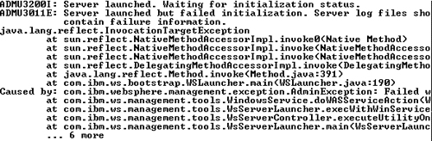

**Figure 3-35. InvocationTargetException error**

[Figure 3-36](https://www.safaribooksonline.com/library/view/websphere-application-server/9781583470619/ch03.html#ch03fig36) shows the exception as it appears in the SystemOut.log file after starting the server.

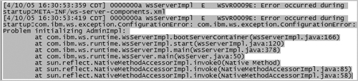

**Figure 3-36. Invocation target exception in SystemOut.log file**

To start the application server, do one of the following:

* Create a DNS entry for the host name you used during the installation.
* Specify the host name you used during the installation in the etc/hosts file. (The directory location of the hosts file varies from operating system to operating system. On Windows, you’ll find it in C:\Windows\System32\drivers\etc. On Unix, it’s in /etc.)

Solution 2. Do you have multiple network interface cards on the same machine? This problem occurs on hosts that have multiple NICs installed (each with a different IP address). To diagnose the issue, ping the host name you used during the installation. Do you see the appropriate IP address configured for that host name (DNS entry)? If you don’t, you need to change your network connection settings:

1. Click the Windows **Start** button, and navigate to **Control Panel|Network Connections**.
2. On the **Advanced** menu, select **Advanced Settings**.
3. On the resulting display ([Figure 3-37](https://www.safaribooksonline.com/library/view/websphere-application-server/9781583470619/ch03.html#ch03fig37)), select the appropriate network connection in the**Connections** list, and click the up arrow to make the connection appear as the first entry. Then click **OK.**

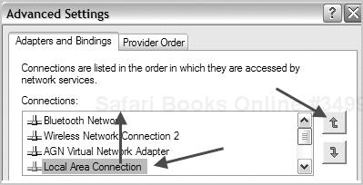

**Figure 3-37. Network Connections advanced settings**

1. Reboot the machine, and restart the application server.

Problem: While starting the server, you receive an error saying, “Conflict detected on port 8880; an instance of the server is already running.”

[Figure 3-38](https://www.safaribooksonline.com/library/view/websphere-application-server/9781583470619/ch03.html#ch03fig38) shows what this error looks like. To address the issue:

1. Determine the status of server1 by issuing the command **serverStatus.bat server1** or**serverStatus.bat –all** from the <PROFILE-ROOT>\bin directory. If the status report shows that server1 is STARTED, the server wasn’t the problem unless you can’t connect through the admin console. (If that is the case, see the solution steps above to troubleshoot the admin console connection.)
2. If you see the status of server1 as STOPPED, the java process may be hanging for various reasons. In such cases, kill that process and restart the application server (server1). To do so, open the Windows Task Manager and terminate the java.exe process by right-clicking on the process and then clicking**End Process** on the shortcut menu. Note: Before killing the process, make sure it has the same process ID as that indicated in SystemOut.log (see [Figure 3-39](https://www.safaribooksonline.com/library/view/websphere-application-server/9781583470619/ch03.html#ch03fig39)) or the .pid file in the application server’s log directory.

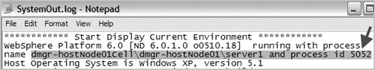

**Figure 3-39. Java process ID in SystemOut.log file**

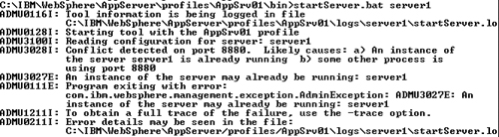

**Figure 3-38. Port 8880 conflict error message**

### **Unix note**

On Unix systems, use the **ps –ef | grep java** command to find the java process, and then kill it using the **kill –9** command. Caution: Because the node agent process also appears in this listing (if you’re in a Network Deployment environment with federated nodes), be sure to direct the kill signal to the right JVM.